Trunk-based development (TBD) is a branching model for software development where developers merge every new feature, bug fix, or other code change to one central branch in the version control system. This branch is called “trunk”, “mainline”, or in Git, the “master branch”.

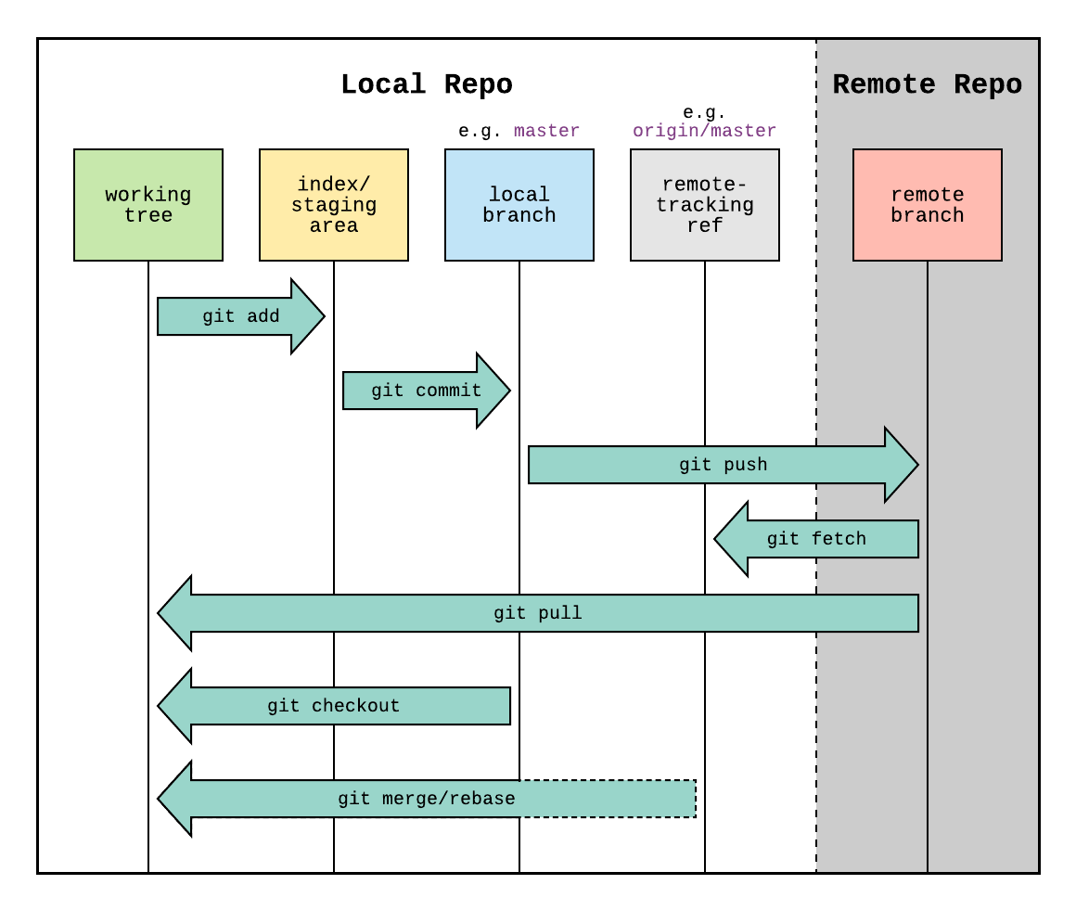

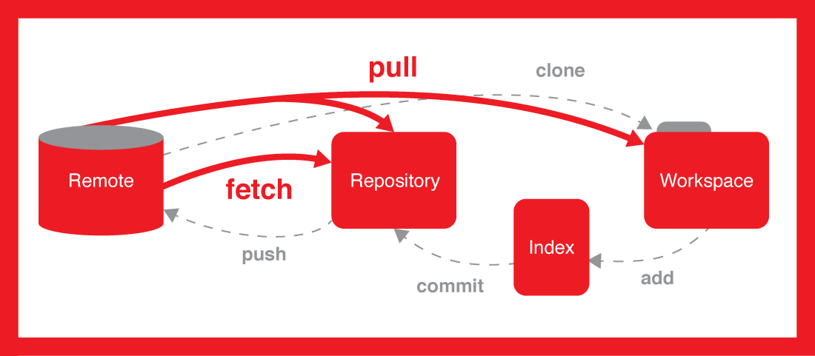

A bare repository is the same as default, but no commits can be made in a bare repository. The changes made in projects cannot be tracked by a bare repository as it doesn’t have a working tree.

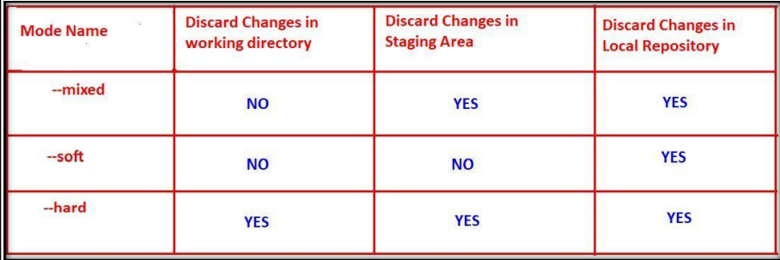

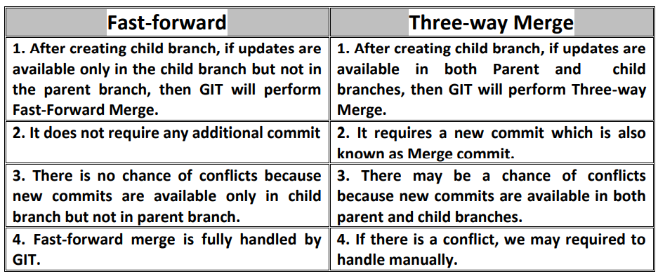

pipeline {

agent ubuntu_docker

stages {

stage('Log the Jenkins Docker Ant Git and Java version info') {

steps {

sh 'ant -version'

sh 'java -version'

sh 'git --version'

}

}

}

}

